2015-2016 Teen/ Artist Project Student Application
The Modern’s Teen/Artist Project pairs area high school students with artists as teachers and aims to expand students’ art practices, introducing new concepts, artists, and media. Throughout the course of the program, students will work with five professional artists. Each visiting artist leads students through an investigation of modern and contemporary art in the galleries and related projects in the Museum studio. Participants will also visit museums and galleries throughout the Dallas/Fort Worth metroplex, introducing them to the area’s art collections and resources. Fifteen students will be accepted to participate in the eight-month course based on their applications and accompanying materials. Class sessions meet at the Modern from 2 to 5 pm most Sundays, September through April, and the program is free of charge for those 10th, 11th, and 12th grade students accepted. Students are required to make a firm commitment to the program, attending class regularly and must be available for one weekend in May during the Annual Teen/Artist Project Exhibition. As a TAP participant, you will:
- Become familiar with the Modern as a resource
- Engage in dialogue about contemporary art
- Learn to talk about your own work
- Strengthen studio techniques by working with professional artists
- Participate in and support an art exhibition
- Explore area galleries, museums, and art spaces

Application Requirements
Deadline: 5pm, September 4, 2015
1. Completed application
2. Answers to application questions on a separate page
3. One letter of recommendation from an adult outside your family
4. Three to five examples of your own work (include title, medium, and year completed). Work can be 2D, 3D, installation, or video—you may submit photographs, color copies, or digital files (on a CD/DVD). Please, DO NOT send original works of art.

Send all materials to:
Jesse Morgan Barnett
Assistant Curator of Education
Modern Art Museum of Fort Worth
3200 Darnell Street
Fort Worth, TX 76107
817.840.2141

APPLICATION
Deadline: September 4, 2015

First Name __________________________________________________________________________

Last Name __________________________________________________________________________

Street ______________________________________________________________________________

City _____________________________________ Zip _______________________________________

High School _________________________________________________________________________

Are you enrolled in art classes at school? _____________________________________________________

Grade & Age ________________________________________________________________________

Cell Phone ___________________________________Home Phone _____________________________

E-mail ______________________________________________________________________________

Emergency Contact Person ___________________________Phone ______________________________

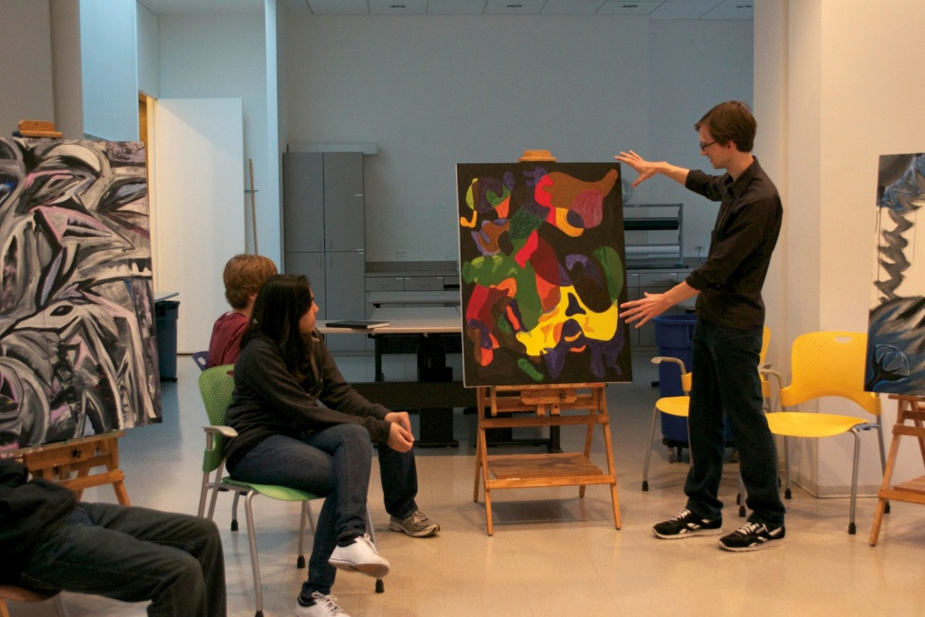

ABOUT YOU

Please answer the following questions on a separate sheet of paper and include with your application:

- In two to three paragraphs, write about why you would like to participate in the Teen/Artist Project at the Modern.

- Tell us about your interests outside of the classroom, especially volunteer and extracurricular activities.

- What encouraged you to become an artist and what is your favorite medium?

- Who are a few artists, writers, celebrities, or historical figures that you find interesting? Please describe why.

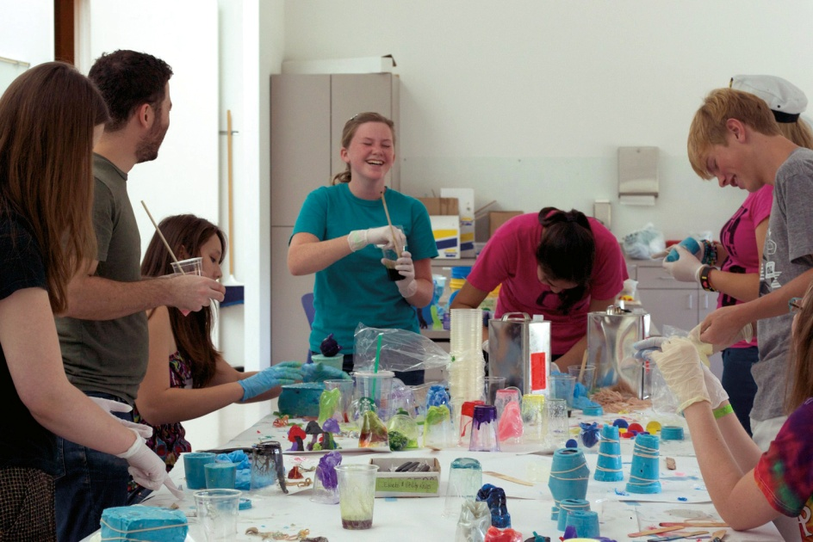

PARENTAL PERMISSION
If accepted, the student and I understand that he/she must make a serious commitment to the Teen/Artist Project and will be expected to have transportation to the Museum. I understand that the program (2015-2016) takes place most Sundays from 2 to 5 pm from September through April and that, if their work is chosen for exhibition, the student will be required to commit to additional weekend gallery days in May. I understand that students may be dismissed from the program or not have work included in the Teen/Artist Project exhibition if they do not attend class on a regular basis.

Parent/Guardian’s Name ___________________________________________
Parent/Guardian’s Signature_________________________________________
Student’s Signature ________________________________________________
Date___________________________________________________________

